BLACK HISTORY MONTH 2025
Events (NESCol)

Monday 27th October:
Film Showcase – “I Am Not Your Negro” by James Baldwin: organised by NESCol Social Science Society. The film explores racism in America through the stories of Medgar Evers, Malcolm X and Martin Luther King Jr.
Be challenged and changed!
Time: 11:00 to 13:00
Venue: Aberdeen City Campus, South Block, SG1 (Lecture Theatre)

Tuesday 28th October:
Hate Crime Awareness: organised by Police Scotland.
Educating and information on hate crimes and non-crime hate incidents, and what you can do if you, or someone you know, is a victim.
Time: 10:00 to 11:00
Venue: Aberdeen City Campus, South Block, SG1 (Lecture Theatre)

NESCol Conversations: Being Black in Scotland
A brave safe space to talk about the experience of being black in Scotland and at NESCol. Be listened to not for a reply, but be heard for understanding, empathy and action.
Time: 12:00 to 13:15
Venue: Aberdeen City Campus, Tower Block, Room LG4

Film Showcase – “I Am Not Your Negro” by James Baldwin: organised by NESCol Social Science Society. The film explores racism in America through the stories of Medgar Evers, Malcolm X and Martin Luther King Jr.
Be challenged and changed!
Time: 17:00 to 19:00
Venue: Aberdeen City Campus, South Block, SG1 (Lecturer Theatre)

Wednesday 29th October:
NESCol Conversations: Being Black in Scotland
A brave safe space to talk about the experience of being black in Scotland and at NESCol. Be listened to not for a reply, but be heard for understanding, empathy and action.
Time: 12:15 to 14:00
Venue: Aberdeen City Campus, Tower Block, Room LG4

Thursday 30th October:
Discussion Panel: Topic is “Moving from Non-Racist to Anti-Racist: Our Collective Responsibility in the North East”. Panellists will include academics, politicians/policy makers and students.
Time: 10.00 to 11.30
Venue: Microsoft Teams

Music Lecture: The life of Julius Eastman. Dr Paul Tierney will deliver an exciting lecture on the enigmatic, remarkable story of Julius Eastman, an African American classical music composer-performer. Paul will also perform some of the work of Julius Eastman.
Time: 15:00 to 16:00
Venue: Aberdeen City Campus, Tower Block, B4 (Basement)

Friday 31st October:
NESCol Conversations: Being Black in Scotland
A brave safe space to talk about the experience of being black in Scotland and at NESCol. Be listened to not for a reply, but be heard for understanding, empathy and action.
Time: 12:15 to 14:00
Venue: Aberdeen City Campus, Tower Block, Room LG4


Music Showcase – BHM Open Mic/Karaoke Call Out: organised by NESCol Music students. Come and have fun and sing your favourite songs from inspirational black artists like Witney Houston, Usher, Beyonce, Marvine Gaye, Jimi Hendrix, Stormzy, Bob Marley, Rihanna, Jay-Z and many others.
Time: tbc
Venue: Aberdeen City Campus, tbc

The Book Showcase, organised by NESCol Library Services, will run throughout the whole week in the libraries at all campuses. This will include book stands with books from inspirational black authors and biographers.
- Click here to view a reading list of some recommended physical books from the library
- Click here for recommended audiobooks from NESCol’s online Libby platform
- Click here to access a ClickView playlist of video content (films, TV programmes, documentaries, etc)

Events (Local Partners)
Aberdeen City Council
Hate Crime Awareness Workshop
Date: 17th October 2025
Time: 10:00 – 11:30 (doors open from 9:45 am)
Location: Town and County Hall – Town House, Aberdeen
The event is free but booking essential.
Please use this link to book: Aberdeen City Council Event Booking System or email Baldeep McGarry if you have access requirements.

University of Aberdeen
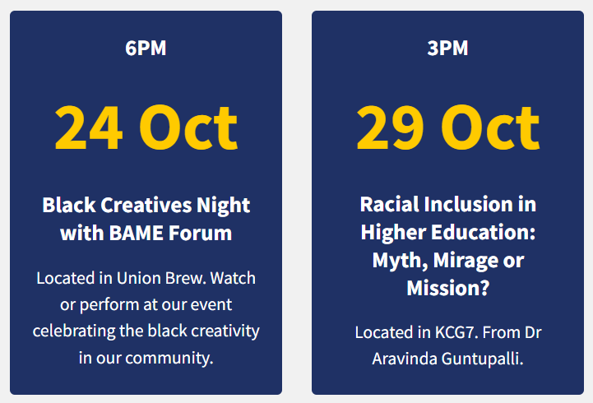

Robert Gordon University
Black History Month 2025 Conference:
The 2025 Black History Month Conference is more than just an event, it’s an opportunity to learn, connect, and contribute to shaping a more inclusive future.
Date: 29th October 2025
Time: 12:30 – 14:30
Location: Innovation Station, Sir Ian Wood Building
Free and open to all. Complimentary lunch and light refreshments will be provided.
Click here for registration. For more information about this event, contact: Chioma Onoshakpor

Catwalk Meets Culture: RGU
Come and experience a world where fashion is more than fabric. After turning heads at London Fashion Week 2023, Kelikume Fashion and Styling is back, and this time, it’s bigger, bolder, and right here in Aberdeen.
Date: 31st October 2025
Time: 18:30 – 22:30
Location: Norwood Hall Hotel, Garthdee Road, Aberdeen, AB15 9FX
Free and open to all. Complimentary lunch and light refreshments will be provided.
For more information about this event, contact: Chioma Onoshakpor

Resources
https://www.blackhistorymonth.org.uk/black-history-month-resource-pack-2025/
https://www.blackhistorymonthscotland.org/resources
https://theblackcurriculum.com/
https://literacytrust.org.uk/resources/celebrate-black-history/
https://neu.org.uk/advice/classroom/teaching-resources/black-history-month-resources
https://www.bbc.co.uk/teach/articles/zjwf8xs#zjxxfdm

